Lincoln Youth Wrestling Tournament

Friday, December 21, 2018
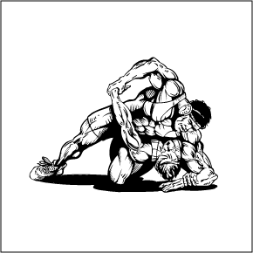
LOCATION: Lincoln High School 2900 S. Cliff Ave, Sioux Falls, SD 57105
WEIGH-INS: 4:00-5:30pm. Wrestling will begin soon after.
DIVISIONS: PreK-K
1st – 2nd Grade
3rd – 4th Grade
5th – 6th Grade

PreK/K will run first. Girls will wrestle girls.
4 OR 5 MAN ROUND ROBIN – THREE (3) – 1:30 PERIODS – High School Rules
AWARDS WILL BE GIVEN FOR ALL PLACES. CHAMPIONS WILL RECEIVE A Trophy, all others will receive Medals
ENTRY FEES: Wrestlers $10:00 at the door. Adults $5.00 Students $3.00 Coaches band: $5.00

Concessions will be served throughout the tournament
*****NO COOLERS*****

______________________________________ENTRY FORM – RETURN THIS PORTION WITH ENTRY FEE____________________________________
Name:____________________________________________ Grade:__________ Age:____________
Town/Club:__________________________________________ Weight:_______________
Address:____________________________________________ Home Phone:______________________
State:_________ Zip:_________________
EXPERIENCE (Circle One): BEGINNER AVERAGE GOOD
I certify that _______________________________is in the __________ grade and has my permission to compete in the Lincoln Youth Wrestling Tournament. I hereby accept full responsibility for his/her behavior and participation. I agree to not hold the Sioux Falls School District / Lincoln Youth Wrestling or its members or agents responsible for injury or accident to my child or for lost items. Parents of wrestlers are responsible for providing insurance for the wrestler listed above.
Signed:____________________________________________ Date:_____________________
Tournament Directors
Mark Ernster – 605-310-9371 mark.ernster@k12.sd.us
Todd Wells – 605-359-2126 todd.wells@k12.sd.us

